**VISVESVARAYA TECHNOLOGICAL UNIVERSITY**

Jnana Sangama, Belagavi, Karnataka - 590 018

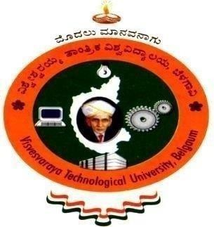

AN INTERNSHIP REPORTON

# “PYTHON WITH MACHINE LEARNING”

**SUBMITTED BY**

**ANAGHA UNNI 1RI20CS006**

### Internship Carried Out At “KARUNADU TECHNOLOGIES PRIVATE LIMITED”

#### Under the guidance of

**EXTERNAL GUIDE INTERNAL GUIDE**

**Mr. SUNIL KUMAR Prof. SHRUTHI S**

**Manager, Assistant Professor,**

**Karunadu Technology, Bengaluru Department of CSE, RRIT**

In partial fulfillment of the award of degree of

### BACHELOR OF ENGINEERING IN COMPUTER SCIENCE AND ENGINEERING

**DEPARTMENT OF COMPUTER SCIENCE AND ENGINEERING R R INSTITUTE OF TECHNOLOGY**

Bengaluru, Karnataka – 560 090

2023-24

R R INSTITUTE OF TECHNOLOGY

Chikkabanavara, Bengaluru - 560 090

### DEPARTMENT OF COMPUTER SCIENCE AND ENGINEERING



**CERTIFICATE**

This is to certify that the Internship entitled **“PYTHON WITH MACHINE LEARNING”** is a bonafide work carried out by **ANAGHA UNNI** bearing **USN: 1RI20CS006** in partial fulfillment for the award of degree in Bachelor of Engineering in Computer Science Engineering from Visvesvaraya Technological University, Belagavi during the academic year 2023-24. It is certified that all the corrections/suggestions indicated for internal assessment have been incorporated in the report submitted in the department Library. This internship report (18CSS84) has been approved as it satisfies the academic requirements in respect of internship report prescribed for award of said degree.

|  |  |  |
| --- | --- | --- |
| **….…………………………….** | **..….……………………..** | **….……………………** |
| **Signature of Internal Guide** | **Signature of HOD** | **Signature of Principal** |
| **[Prof. Shruthi S]** | **[Dr. Manjunath R]** | **[Dr. Mahendra K V]** |
| Assistant professor, | Professor and Head | Principal |
| Department of CSE, RRIT | Department of CSE, RRIT | RRIT, Bengaluru |

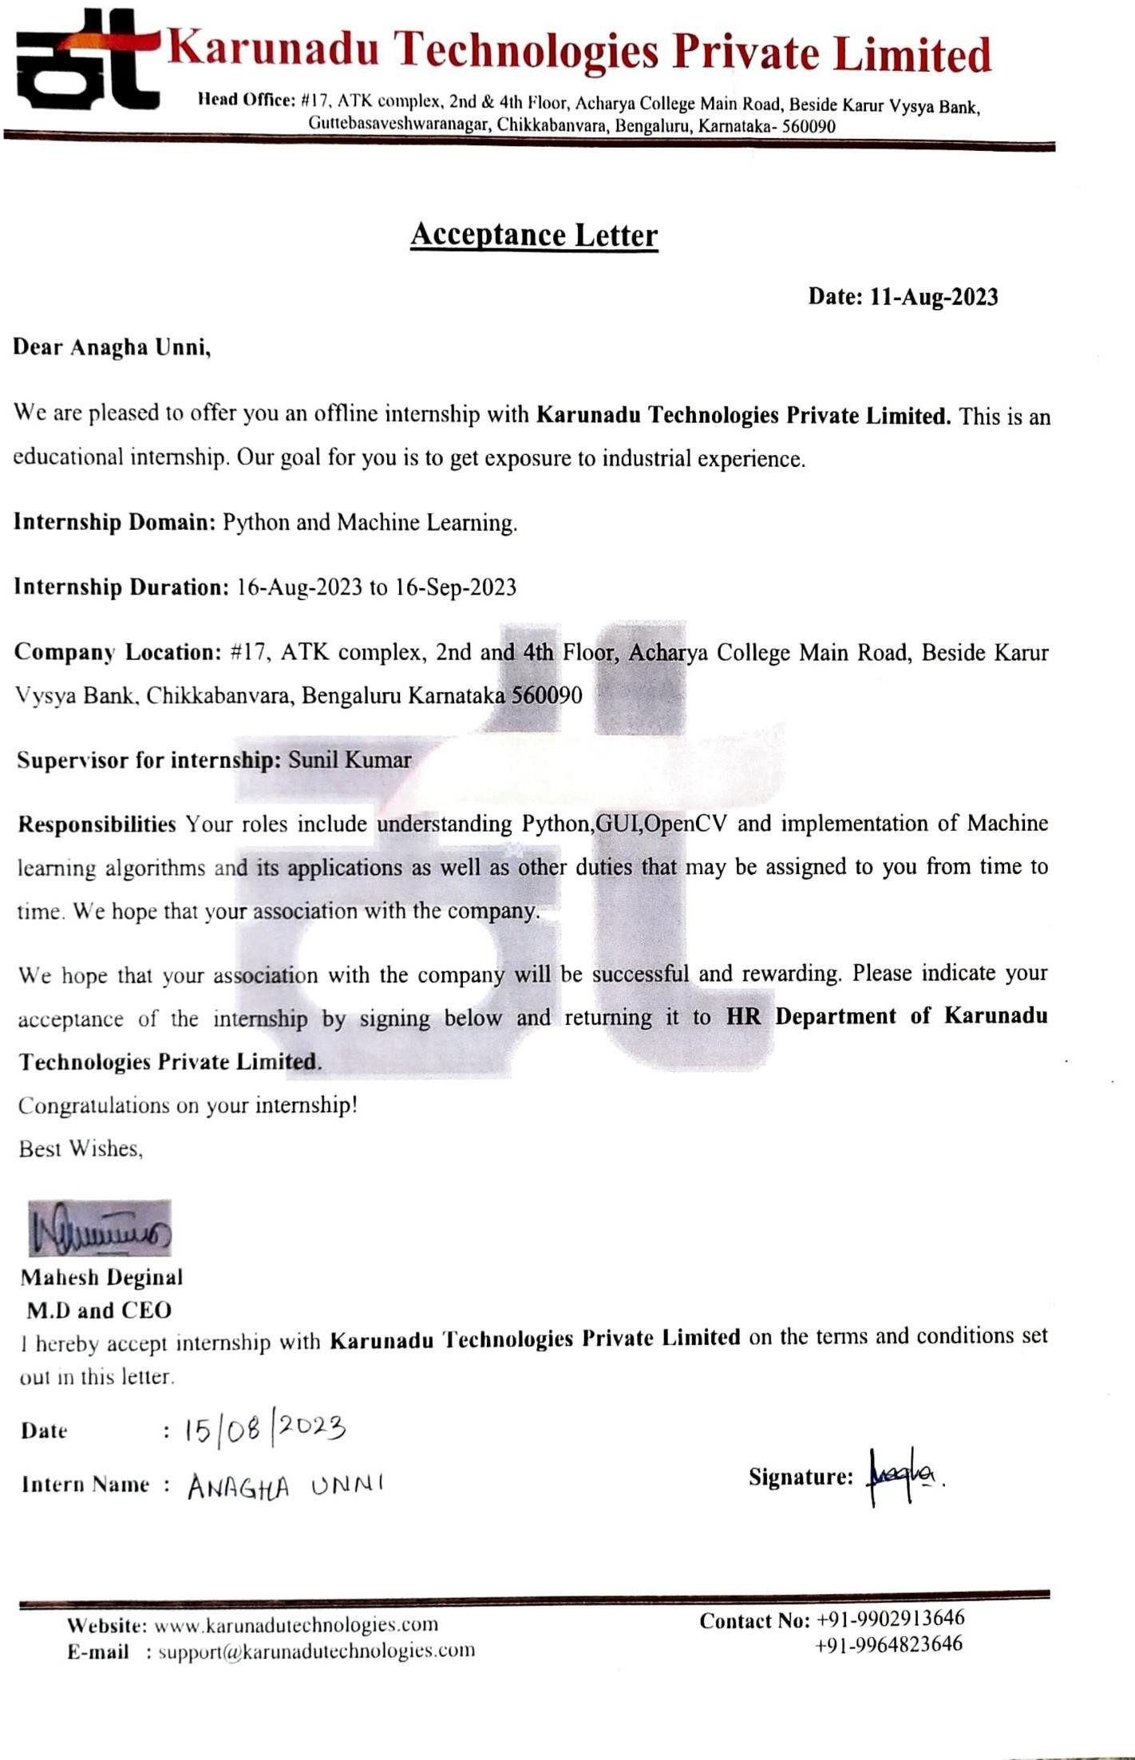

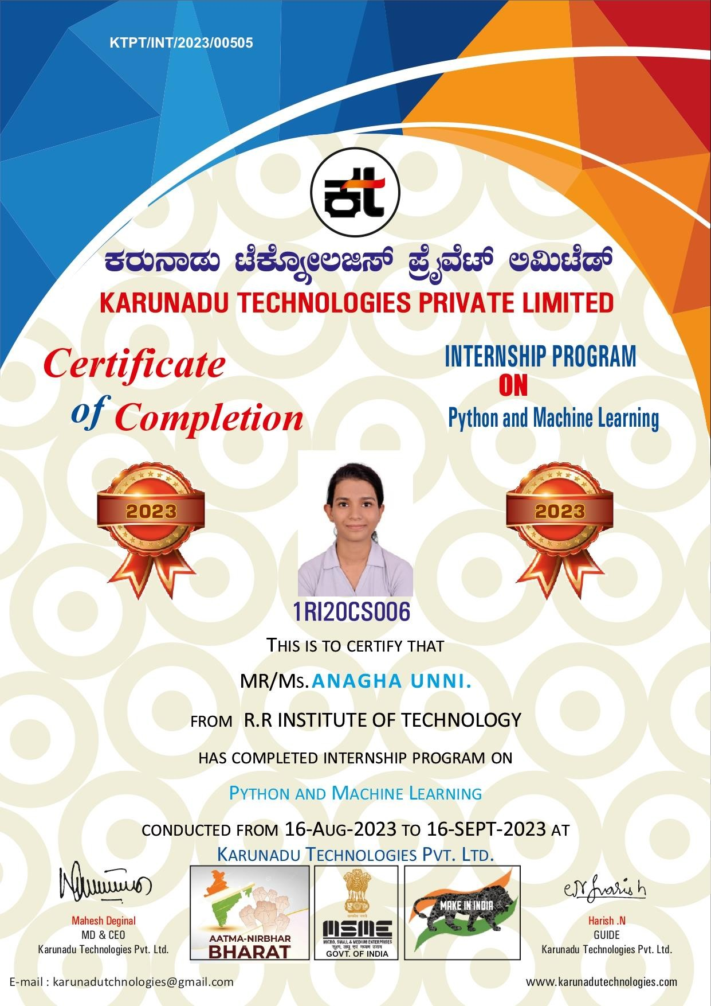

# DECLARATION

I **ANAGHA UNNI**, student of 7th Semester B. E in the Department of Computer Science and Engineering, RRIT, Bangalore - 560090, hereby declare that the Internship entitled **“PYTHON WITH MACHINE LEARNING”** has been carried out under the supervision of **Prof. Shruthi S** Assistant Professor of CSE, RRIT**,** submitted in partial fulfillment of the source requirements for the award of degree in Bachelor of Computer Science and Engineering **Visvesvaraya Technological University, Belagavi** during the academic year 2023-24

PLACE : BENGALURU NAME : ANAGHA UNNI DATE : USN :1RI20CS006

# ACKNOWLEDGEMENT

I consider it a privilege to whole-heartedly express our gratitude and respect to each and every one who guided and helped us in the successful completion of this report.

I am grateful to **Dr. Mahendra K V,** Principal, RRIT, Bangalore, and all staff members of the Computer Science and Engineering Department for their kind cooperation.

I am extremely grateful to **Dr. Manjunath R**, Professor and Head, Department of Computer Science and Engineering**,** for his cooperation and encouragement. I thank him for providing me w i t h an opportunityto carry out this Internship at Karunadu Technologies Private Limited.

I express my deepest gratitude and sincere thanks to our internship coordinator **Prof. Revathi B,** Assistant Professor, Department of Computer Science & Engineering, and Guide **Prof. Shruthi S,** Assistant Professor, Department of Computer Science and Engineering for their valuable guidance during the course of this internship. I thank them for providing me an opportunity to carry out the internship at Karunadu Technologies Private Limited, Bengaluru.

Finally, it’s a pleasure and happiness to the friendly co-operation showed by all the staff members, friends of Computer Science and Engineering department.

**ANAGHA UNNI 1RI20CS006**

**TABLE OF CONTENTS**

|  |  |  |
| --- | --- | --- |
| **SL NO** | **CONTENTS** | **PAGE**  **NO** |
| **1** | **CHAPTER 1: Company Profile** | **1** |
|  | 1.1.Profile | 1 |
|  | 1.1.1. Vision | 1 |
|  | 1.1.2. Mission | 1 |
|  | 1.1.3. Objectives | 2 |
|  | 1.2.Company Products And Services Offered | 2 |
|  | 1.2.1. Products | 2 |
|  | 1.2.2. Services | 3 |
|  | 1.3.Contact Details | 4 |
| **2** | **CHAPTER 2: Department Profile** | **5** |
| **3** | **CHAPTER 3: Tasks Assigned** | **6** |
|  | 3.1. Introduction | 6 |
|  | 3.2. Project Description | 6 |
|  | 3.3. Programming Steps | 6 |
|  | 3.4. Smoker Status Prediction Using Random Forest Algorithm | 7 |
|  | 3.5. Predict Satisfaction Levels Of The Customers Using Naïve  Bayes | 10 |
| **4** | **CHAPTER 4: Reflection Notes** | **13** |
| **5** | **CHAPTER 5: Results** | **14** |
|  | 5.1. Smoker Status Prediction | 14 |
|  | 5.2. Predict Satisfaction Levels Of The Customers | 16 |
| **6** | **CHAPTER 6: Conclusion** | **19** |

|  |  |  |
| --- | --- | --- |
| **FIG NO** | **DESCRIPTION** | **PAGE**  **NO** |
| 1.1 | Company logo | 1 |
| 3.1 | Overview dataset | 8 |
| 3.2 | Code for smoker status prediction | 8 |
| 3.3 | Implementing smoker status prediction in Django | 9 |
| 3.4 | Overview dataset | 11 |
| 3.5 | Code for customer satisfaction prediction | 12 |
| 3.6 | Implementing customer satisfaction prediction in Django | 12 |
| 5.1 | Output for smoker status prediction | 15 |
| 5.2 | Output of smoker status prediction web interface | 15 |
| 5.3 | Output of customer satisfaction prediction | 17 |
| 5.4 | Django output for customer satisfaction prediction | 18 |

**CHAPTER 1**

# COMPANY PROFILE

It is a pleasure to introduce “Karunadu Technologies Private Limited” as a leading IT software solutions and services industry focusing on quality standards and customer values. It is also a leading Skills and Talent Development company that is building a manpower poolfor global industry requirements.

### Profile



#### Fig 1.1 Company Logo

The company offers broad range of customized software applications powered by concrete technology and industry expertise. It also offers end to end embedded solutions and services. They deal with broad range of product development along with customized features ensuring at most customer satisfaction and also empower individual with knowledge, skills and competencies that assist them to escalate as integrated individuals with a sense of commitment and dedication.

### Vision

To Empower Unskilled Individual with knowledge, skills and technical competencies in the field of Information Technology and Embedded engineering which assist them to escalate as integrated individuals contributing to company’s and Nation’s growth.

### Mission

* + - * Provide cost effective and reliable solutions to customers across various latest technologies.
      * Offer scalable end-to-end application development and management solutions
      * Provide cost effective highly scalable products for varied verticals.
      * Focus on creating sustainable value growth through innovative solutions and unique partnerships.
      * Create, design and deliver business solutions with high value and innovation by leveraging technology expertise and innovative business models to address long-term business objectives.
      * Keep our products and services updated with the latest innovations in the respective requirement and technology.

### Objectives

* + - * To develop software and Embedded solutions and services focussing on qualitystandards and customer values.
      * Offer end to end embedded solutions which ensure the best customer satisfaction.
      * To build Skilled and Talented manpower pool for global industry requirements.
      * To develop software and embedded products which are globally recognized.
      * To become a global leader in Offering Scalable and cost-effective Software solutions and services across various domains like E-commerce, Banking, Finance, Healthcare and much more.
      * To generate employment for skilled and highly talented youth of our Country INDIA.
  1. **Company Products and Services Offered**

### Products

#### KECMS – Karunadu Enterprise Content Management System

Karunadu Enterprise Content Management System is a one stop solution for all our enterprise content management System relating to digital asset management, document imaging, workflow systems and records management systems. Increasing digitalization has led to an exponential growth in business content and managing this sea of unstructured data istedious work. KECMS enables you to create, capture, manage, distribute, archive different forms of content and has much more features.

#### KEMS – Karunadu Education Management System

Manage diversified data relating to education management on cloud. Educational dataincluding students and staff is gathered over years which contain information from admission/appointment until leaving the Education. Statistical reports for the College/school can be generated along with admission Tracking and result analysis to keep track of progressive improvements of both student and staff.

#### KASS – Karunadu Advanced Security System

A Complete one stop embedded solution for large apartments. Security system which monitors door breakage, window breakage, gas leakage, motion detection and various other features which can be operated and maintained by centralized monitored system. This Embedded solution enhances the security measures of apartment/building and enhances the security of individuals may be from unintended intervention or from unauthorized access.

### Services

#### IT Solutions and Services

Karunadu Technologies is a Bangalore based IT Training and Software Development center with an exclusive expertise in the area of IT Services and Solutions. Karunadu Technologies Pvt. Ltd. is also expertise in Web Designing and Consulting Services.

#### Embedded Design and Development

Karunadu Technologies Pvt. Ltd. has expertise in Design and development of embedded products and offers solutions and services in field of Electronics.

#### Academic Projects

Karunadu Technologies Pvt. Ltd. helps students in their academics by imparting industrial experience into projects to strive excellence of students. Karunadu Technologies Pvt. Ltd. encourages students to implement their own ideas to projects keeping in mind "A small seed sown upfront will be nourished to become a large tree one day”, thereby focusing

the future entrepreneurs. They have a wide range of IEEE projects for B.E, MTech, MCA, BCA, DIPLOMA students for all branches in each and every domain.

#### In plant Training

Karunadu Technologies Pvt. Ltd. provides Implant training for students according to the interest of students keeping in mind the current technology and academic benefit one obtains after completing the training. Students will be nourished and will be trained throughout with practical experience. Students will be exposed to industrial standards which boost their carrier. Students will become Acquaint to various structural partitions such as labs, workshops, assembly units, stores, and administrative unit and machinery units. They help students to understand their functions, applications and maintenance. Students will be trained from initial stage that is from collection of Project Requirements, Project Planning, Designing, implementation, testing, deployment and maintenance there by helping to understand the business model of the industry. Entire project life cycle will be demonstrated with hands on experience. Students will also be trained about management skills and team building activities. They assure that by end of implant training students will Enhance communication skills and acquire technical skills, employability skills, start-up skills, andwill be aware of risks in industry, management skills and many other skills which are helpful to professional engagement.

#### Software Courses

Karunadu Technologies Pvt. Ltd. provides courses for students according to theinterest of students keeping in mind the current technology and assist them for their further Employment. Company provides various courses such as C, C++, VB, DBMS, Dot Net, CoreJava and J2EE along with live projects.

## Contact Details

Related image#17, ATK complex, 4th Floor, Acharya College Main Road, Beside KarurVysya Bank, Guttebasaveshwaranagar, Chikkabanvara, Bengaluru, Karnataka- 560090

Image result for email icon in black color[support@karunadutechnologies.com](mailto:support@karunadutechnologies.com)

**CHAPTER 2**

## DEPARTMENT PROFILE

Karunadu Technologies is a trailblazing technology solutions provider known for its unwavering commitment to innovation and talent development. With a rich legacy of expertise in cutting-edge technologies, Karunadu Technologies has emerged as a leading force in the industry, delivering state-of-the-art solutions and fostering the growth of aspiring professionals.

#### SKILL DEVELOPMENT AND INTERNSHIP

1. Identifying and training of manpower pool for global industry requirements.
2. Training and development of talents on all leading technologies.
3. Internship is provided for all academic courses to encourage upcoming global talents.
4. Conduct wide range of Training programs which includes courses, workshops, internship, Industrial talks for students and professionals on all latest technologies and trends.

#### REVEIW PAPER WRITING

Help in thesis consultation along with paper reviewing and organize points and relate current work of literature to the thesis

Publish paper on internationally famed journals which include IEEE, SCI, Scopus,Springer, Elsevier, Taylor & Francis, Inder Science, Wiley and so on.

#### RESEARCH PROPOSAL

Help in research proposals during the development process in collaboration with the researcher and their requirements. We can be of great help to you while we develop the proposal in collaboration with you according to your requirements.

**CHAPTER 3**

## TASKS ASSIGNED

### INTRODUCTION

The objective of the internship is to apply theoretical knowledge of “Machine Learning using Python” to solve real time complex problems, in order to achieve these following basic concepts were learned:

* + - Python
    - Machine Learning

Based on the concepts learned, projects were assigned.

### PROJECT DESCRIPTION

The project was done using Python with a Django framework. The projects done were:

* + - **Smoker status prediction using Random Forest algorithm**: Create a machine learning model to identify the smoking status of an individual using bio-signals
    - **Predict satisfaction levels of the customers using Naïve Bayes:** Create a machine learning model to identify whether the customer will be satisfied with the airlines by entering the input details by providing a data set as input to the model

### PROGRAMMING STEPS

* + - Import the required library (here pandas,sklearn,numpy).
    - Import train_test_split from sklearn.model_selection
    - Import StandardScaler from sklearn.preprocessing
    - Import the required algorithm from the library
    - Import confusion_matrix from sklearn.metrics
    - Import accuracy_score from sklearn.metrics
    - Provide the path of data file so that it can be included in our program
    - Analyse the given data set
    - Drop the columns and rows which are not needed
    - Print the inputs and outputs as per the problem statement
    - Create a model and train the model
    - Scale the model (x_train and x_test)
    - Provide the input and let the model predict the output
    - Calculate the accuracy of the model using confusion matrix or by using accuracy_score()
    - Also create the front end using HTML and Django, with bootstrap for framework

### 3.4. Smoker status prediction using Random Forest algorithm

The objective is to create a machine learning model to identify the smoking status of an individualusing bio-signals.

### Dataset

|  |  |
| --- | --- |
| Age | Age of the person |
| Height | Height in cm |
| Weight | Weight in kg |
| Waist | Waist circumference in cm |
| Eyesight (left) | Eyesight in the left eye |
| Eyesight (right) | Eyesight in the right eye |
| Hearing (left) | Hearing of the left ear |
| Hearing (right) | Hearing of the right ear |
| systolic | Systolic blood pressure |
| Relaxation | Relaxation or diastolic blood pressure |
| Fasting blood sugar | Blood sugar level of the individual |
| Cholesterol | Total cholesterol level |
| Triglyceride | Triglyceride levels of the individual |
| HDL | high-density lipoprotein level; a type of cholesterol |
| LDL | low-density lipoprotein level; a type of cholesterol |
| Hemoglobin | The level of hemoglobin in the individual’s blood |
| Urine protein | Protein content level of urine |
| Serum creatinine | Creatinine levels of individual |
| AST | glutamic oxaloacetic transaminase type |

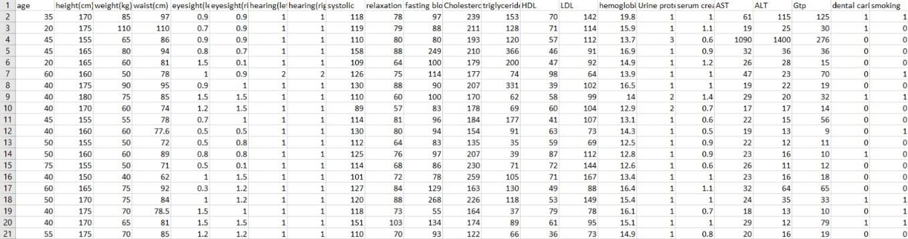

#### Fig 3.1 Overview of Dataset

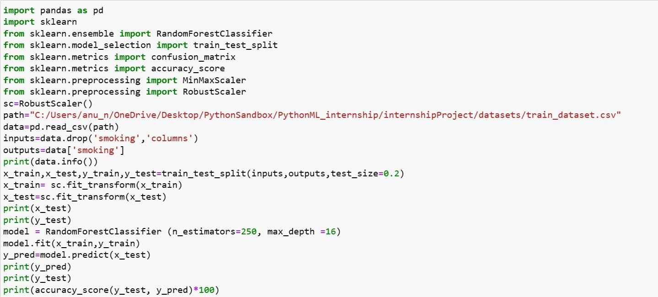The overview of the original dataset is shown in fig 3.1., with its original features: Algorithm **–Random forest**

#### Fig 3.2 Code for smoker status prediction

**Implementing Code using HTML, Django**

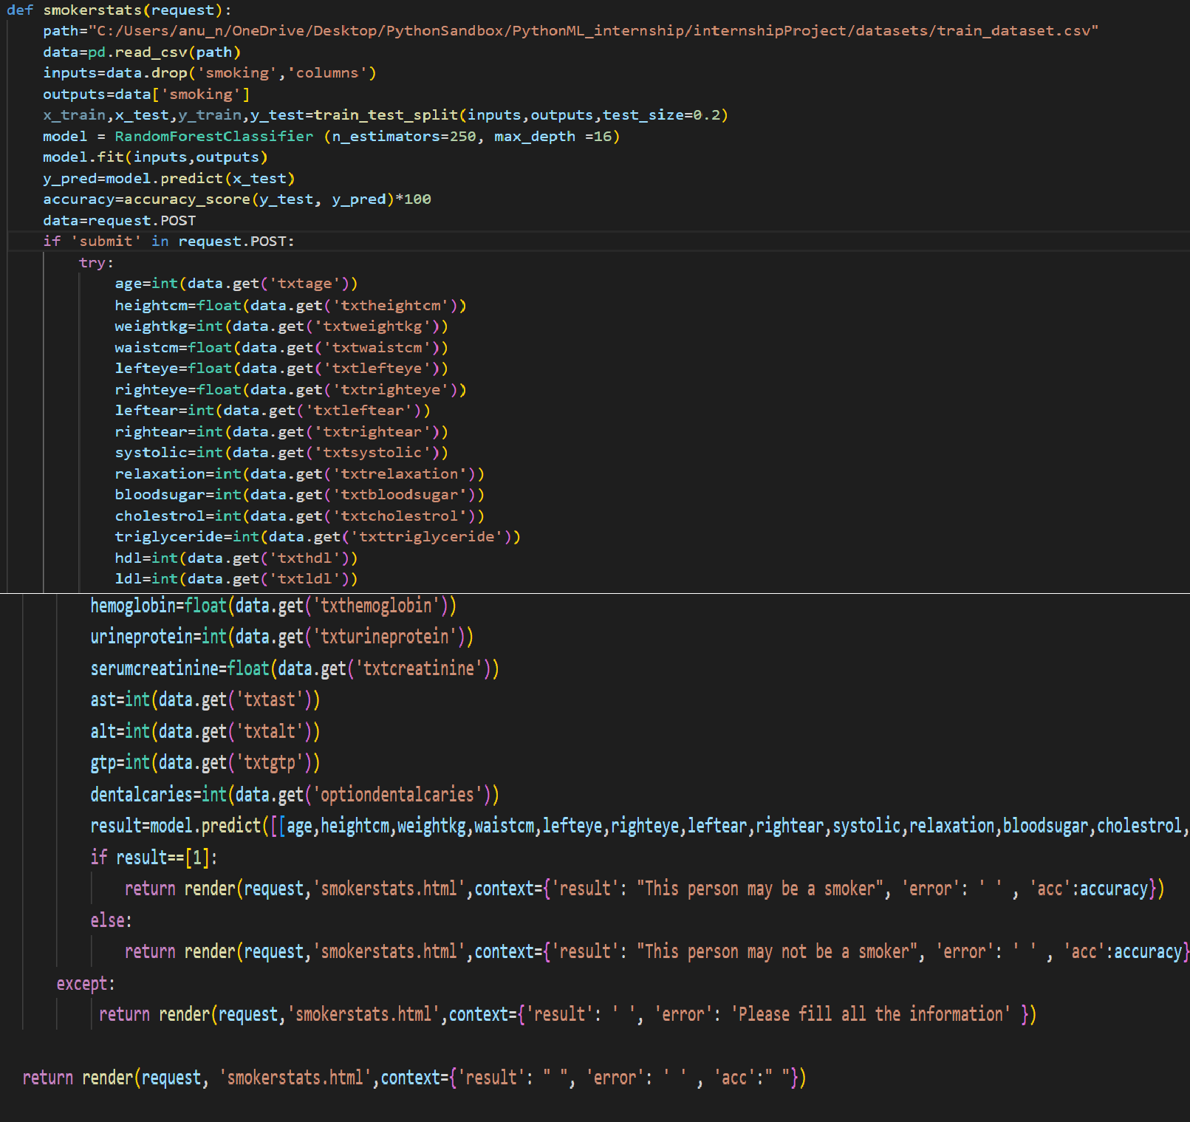

**Fig 3.3 Implementing smoker status prediction in Django**

### 3.5 Predict satisfaction levels of the customers using Naïve Bayes

The objective Is to create a machine learning model to identify whether the customer will be satisfied with theairlines by entering the input details by providing a data set as input to the model

#### Dataset

* Satisfaction: Airline satisfaction level(Satisfaction, neutral or dissatisfaction)"
* Age: The actual age of the passengers
* Gender: Gender of the passengers (Female, Male)
* "Type of Travel: Purpose of the flight of the passengers (Personal Travel,Business Travel)"
* "Class: Travel class in the plane of the passengers (Business, Eco, Eco Plus)"
* Customer Type: The customer type (Loyal customer, disloyal customer)
* Flight distance: The flight distance of this journey
* "Inflight wifi service: Satisfaction level of the inflight wifi service (0:NotApplicable;1-5)"
* Ease of Online booking: Satisfaction level of online booking
* Inflight service: Satisfaction level of inflight service
* Online boarding: Satisfaction level of online boarding
* Inflight entertainment: Satisfaction level of inflight entertainment
* Food and drink: Satisfaction level of Food and drink
* Seat comfort: Satisfaction level of Seat comfort
* On-board service: Satisfaction level of On-board service
* Leg room service: Satisfaction level of Leg room service
* Departure/Arrival time convenient: Satisfaction level of Departure/Arrival timeconvenient
* Baggage handling: Satisfaction level of baggage handling
* Gate location: Satisfaction level of Gate location
* Cleanliness: Satisfaction level of Cleanliness
* Check-in service: Satisfaction level of Check-in service
* Departure Delay in Minutes: Minutes delayed when departure
* Arrival Delay in Minutes: Minutes delayed when Arrival
* Flight canceled: Whether the Flight canceled or not (Yes, No)
* Flight time in minutes: Minutes of Flight takes

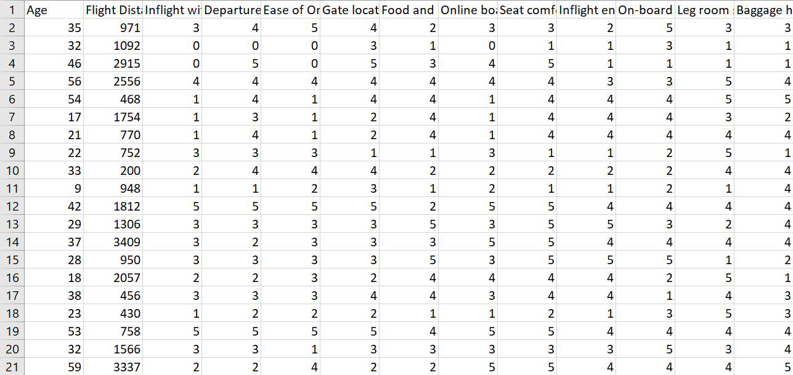

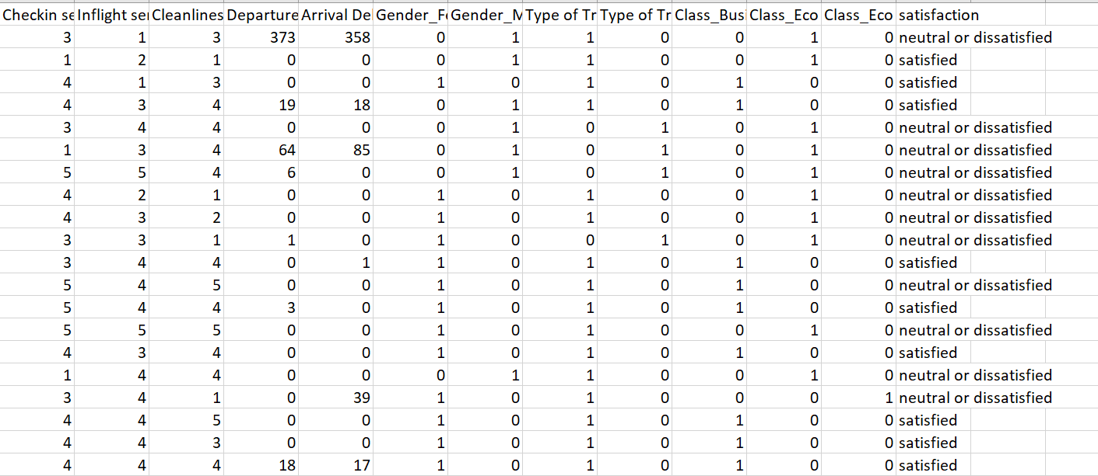

#### Fig 3.4 Overview of Dataset

Algorithm – **Naïve Bayes**

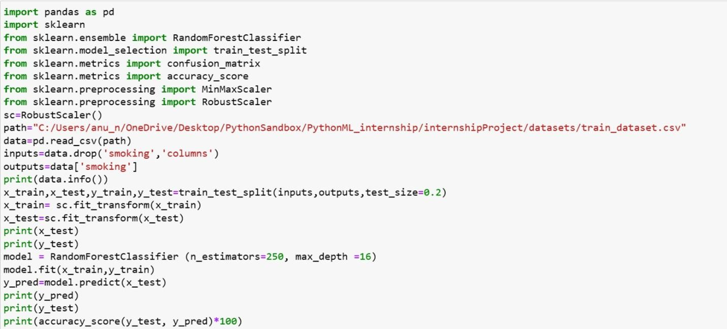

#### Fig 3.5 code for customer satisfaction prediction Implementing Code in Django

**fig 3.6 Implementing Customer Satisfaction Prediction in Django**

**CHAPTER 4**

## REFLECTION NOTES

As per our experience during the internship, Karunadu technologies follows a good workculture and they have friendly employees, starting from the staff level to the management level.

I was assigned various tasks that involved working with different machine-learning algorithms and components. Throughout the internship, I gained knowledge and hands-on experience in Python programming language for Machine Learning so as to apply the theoretical knowledge to solve real-time and complex problems. The internship helped to find appropriate prediction models for the problems by applying suitable learning algorithms that can be used in the future. The internship project assigned by the company helped to improve my programming skills and to implement basic knowledge for solving real-world problem

The trainers are well versed in their area and they treat everyone equally. There is no distinguishing between fresher graduates and corporates and everyone is respected equally. There is a lot of teamwork followed in a task, be it hard or easy and there is a very calm and friendly atmosphere maintained at all times.

The projects I worked on during my internship also taught me the importance of planningand execution. We had to carefully plan out each project, taking into account the requirements, timelines, and resources available, before executing it. This helped us to avoid errors and complete the projects on time and within budget.

There is a lot of scope for self-improvement due to the great communication and support that can be found. Interns have been treated and taught well and all our doubts and concerns regarding the training or the companies have been properly answered.

All in all, Karunadu Technologies was a great place for a fresher to start a career and also for a corporate to boost his/her career. It has been a great experience to be an intern in such a reputed organization.

**CHAPTER 5**

## RESULTS

* 1. **SMOKER STATUS PREDICTION**

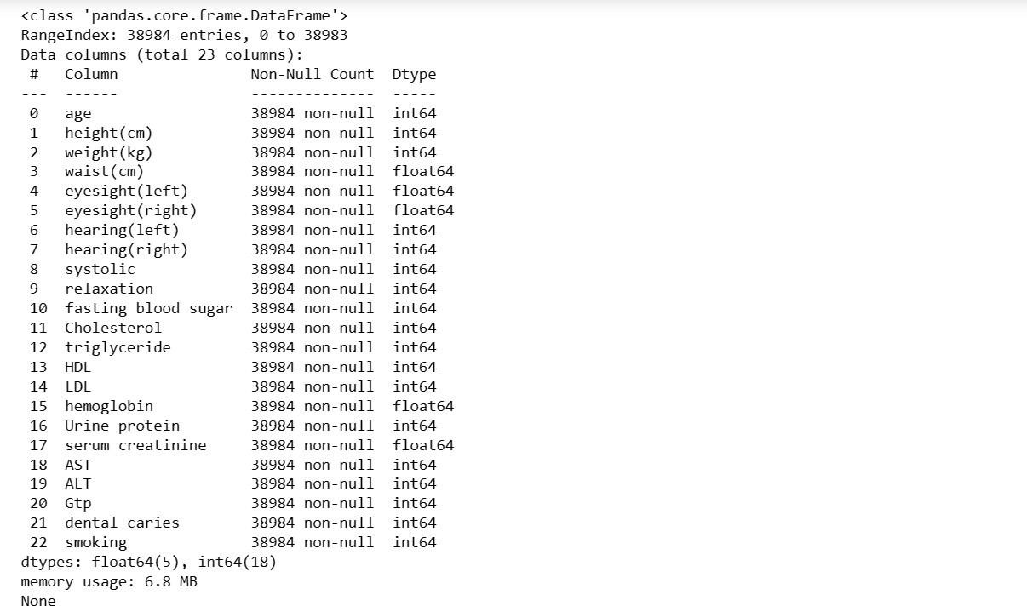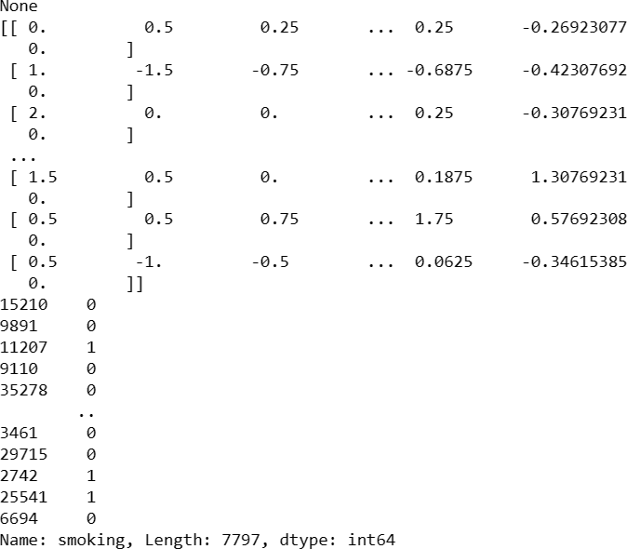

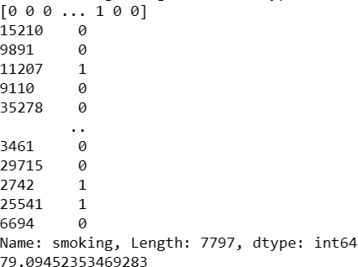

#### Fig 5.1 Output of Smoker status prediction

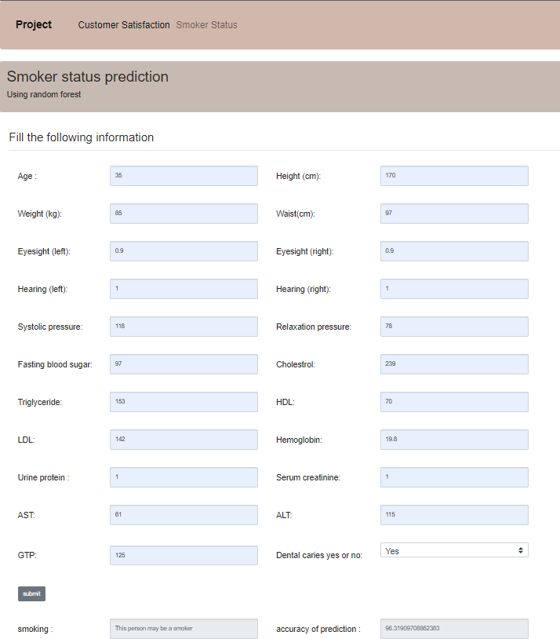

**Fig 5.2 Output of smoker status prediction web interface**

## PREDICT SATISFACTION LEVELS OF THE CUSTOMERS

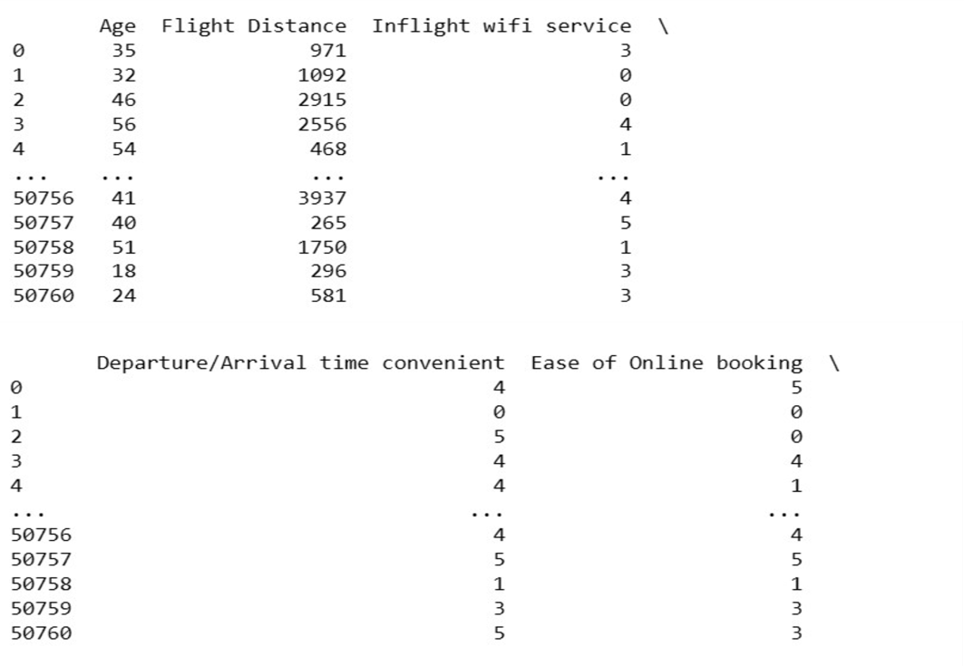

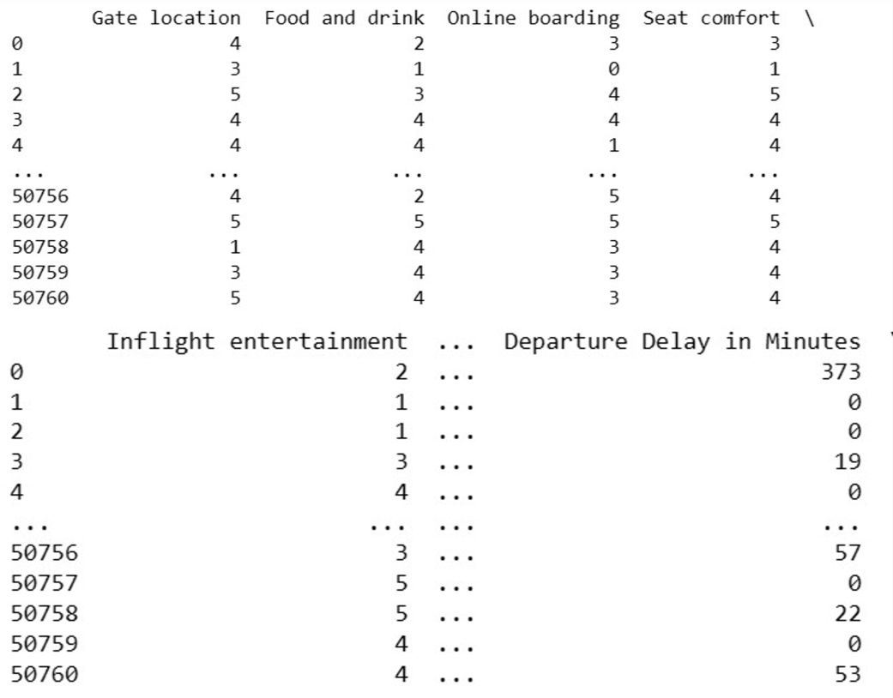

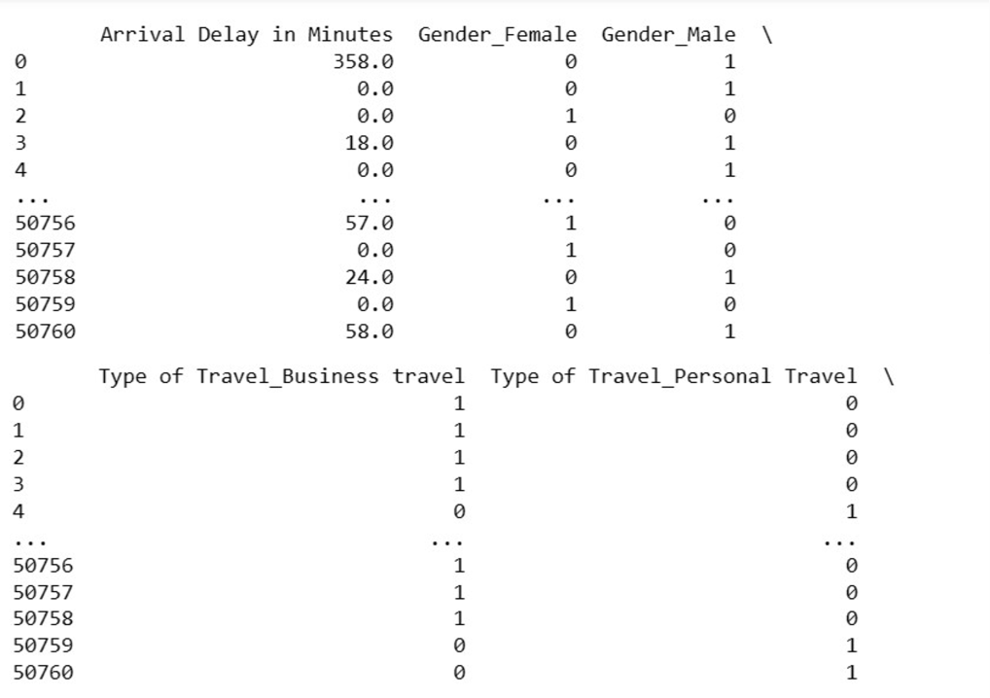

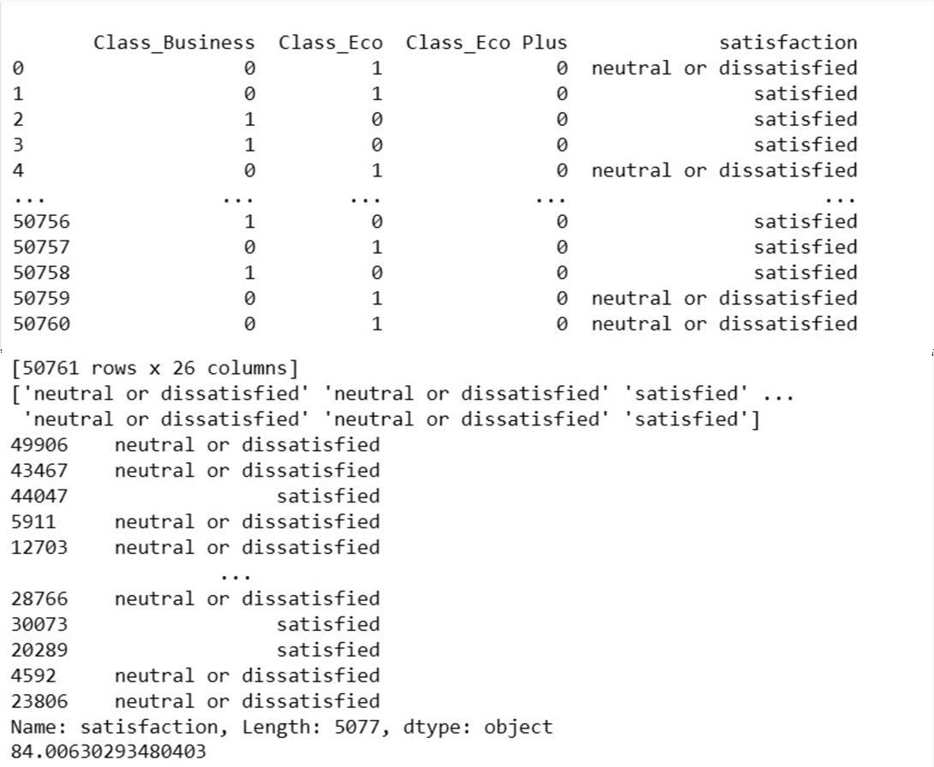

#### Fig 5.3 Output of Customer Satisfaction Prediction

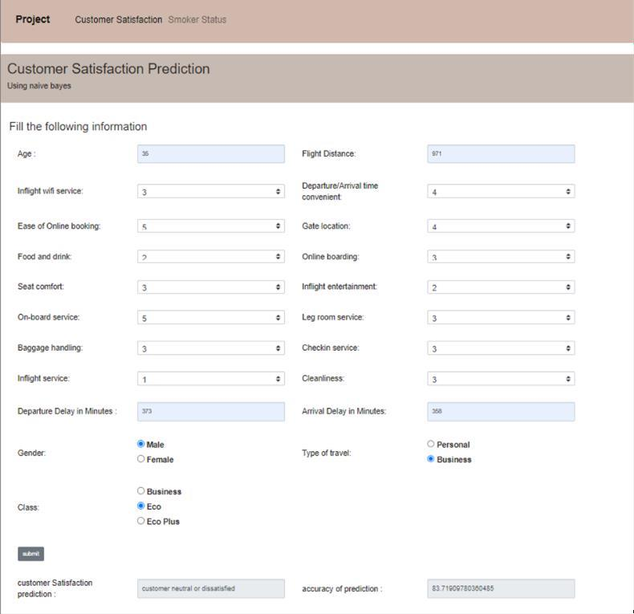

**Fig 5.4 Django output of customer satisfaction prediction**

# CONCLUSION

Machine learning, with its ability to analyze vast datasets and make predictions or decisions without explicit programming, is at the forefront of technological innovation. It has a profound impact on diverse fields, from healthcare and finance to autonomous vehicles and e-commerce. The ability to harness the power of machine learning is not just a competitive advantage; it has become a necessity for organizations seeking to thrive in the modern landscape.

Python, as the programming language of choice for many machine learning applications, plays a pivotal role in this transformative process. Its simplicity, versatility, and extensive libraries make it an ideal tool for developing machine-learning algorithms and models. Python has emerged as the lingua franca of data science and artificial intelligence, enabling professionals to turn complex ideas into practical solutions efficiently.

In this era of rapid technological advancement, where data is the new currency and automation is redefining industries, my internship experience has underscored the importance of machine learning and Python in shaping our world. It has reinforced the notion that staying current with these technologies is not just an option but a fundamental requirement for anyone looking to make a meaningful impact in today's ever-evolving global landscape. As I move forward in my career, I am excited to continue exploring the limitless possibilities that machine learning and Python offer, confident in their significance in shaping the future.

# REFERENCES

* + 1. [www.karunadutechnologies.com](http://www.karunadutechnologies.com/)
    2. [Taiwo Ayodele,](https://www.researchgate.net/profile/Taiwo_Ayodele) “Types of Machine learning algorithms”, 2018
    3. https:/[/www.geeksforgeeks.org/random-forest /](http://www.geeksforgeeks.org/decision-tree/)
    4. https:/[/www.geeksforgeeks.org/naive-bayes /](http://www.geeksforgeeks.org/decision-tree/)